**MySQL Exercise 1**

1. Write a program that computes the perimeter and the area of a rectangle. Define your own values for the length and width. (Assuming that L and W are the length and width of the rectangle, Perimeter = 2*(L+W) and Area = L*W.

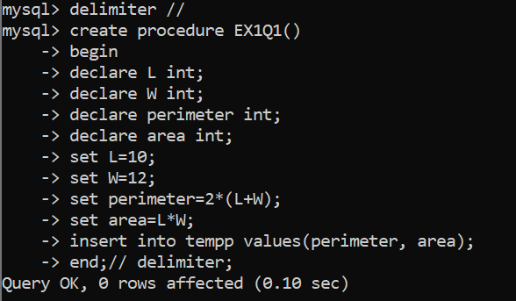

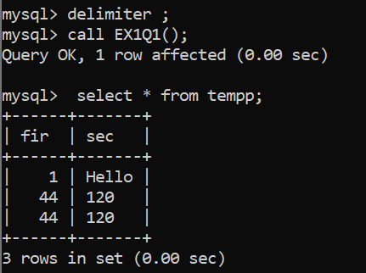

1. Write a program that declares an integer variable called num, assigns a value to it, and computes and inserts into the tempp table the value of the variable itself, its square, and its cube.

Code:

delimiter //

create procedure ABC11()

begin

declare num int default 5;

declare squares int;

declare cubes int;

set squares = power(num,2);

set cubes = power(num,3);

insert into tempp values(squares, cubes);

end;//

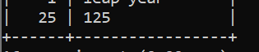

1. Convert a temperature in Fahrenheit (F) to its equivalent in Celsius (C) and vice versa. The required formulae are:- C= (F-32)*5/9 F= 9/5*C + 32

Code:

mysql> delimiter //

mysql> create procedure temp(icel float, ifar float)

-> begin

-> declare C float;

-> declare F float;

-> set C=(ifar-32)*5/9;

-> set F=9/5*(icel)+32;

-> insert into tempp values(C,F);

-> end;

-> //

4. Convert a number of inches into yards, feet, and inches. For example, 124 inches equals 3 yards, 1 foot, and 4 inches.

5. Write a program that enables a user to input an integer. The program should then state whether the integer is evenly divisible by 5.

Code:

delimiter //

create procedure E1Q6(num int)

begin

declare result int;

if num%5=0 then

insert into MySQL_PL_EX1Q5 values(1,'Divisible by 5');

else

insert into MySQL_PL_EX1Q5 values(1,'Not Divisible by 5');

end if;

end;//

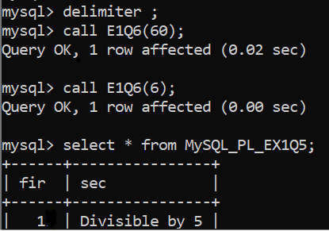

6. Your block should read in two real numbers and tell whether the product of the two numbers is equal to or greater than 100.

